Events
BACK
Upcoming Events.....

Diocese of Fredericton Layreader Gathering September 6th & 7th at Villa Madonna Download brochure here.

Alzheimer's Café Sunday September 15th, 10 am at Holy Trinity Church September is Alzheimer's awareness month! Join us for coffee and yummies Sunday September 15th at 10 am in the church hall. Free will offering with all proceeds for the Alzheimer's Society of New Brunswick.

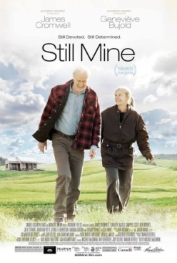

COMMUNITY LUNCH & MOVIE MATINEE! In support of World Alzheimer's Month at Holy Trinity Church 2 Hammond River Rd., Quispamsis (next to the bridge). Friday September 27th, 2019 with lunch from 11am to 1 pm followed by the movie "Still Mine" at 1 pm . This movie is based on the real story of Craig Morrison's struggle with local authorities to build a final home in St. Martin's, NB for his wife Irene who is showing signs of early dementia. Starring James Cromwell & Geneviève Bujold PG 13. Everyone is Welcome! Free will offering to support the Alzheimer's Society of NB. For information contact the parish office at 847-0850.

Growing Together in Faith Events.....

BIBLE STUDY OF BOOK OF ROMANS – Join us Wednesdays at 11:15 am in the Multipurpose Room for an hour of grace and fellowship. Everyone is welcome! Call 847- 0850 for more information.

PRAYER LISTS: Contact the parish office to add a loved one to the prayer list 847-0850

↓

Weekly Events.....
Sundays - All are invited to Worship Service at 9 am with Rev. Michael O'Hara followed by Coffee Hour at 10 am

Mondays - Calico Quilters 10 am to 2 pm contact Karen Kalverboer

Tuesdays - TOPS at 6 pm contact Peggy Hanratty

Tuesdays - Choir practice at 10 AM contact Cindy Dutton

Wednesdays - Bible Study contact parish office 847- 0850 at 11:15 am

Wednesdays - AA meetings 7 pm contact Art Cipryk 650-9929

Thursdays - weekly newsletter Happenings contact Margo Mapplebeck to receive an email copy.

Monthly Events.....
Food Bank Sunday - the last Sunday of each month donations are given to the KV Food Bank

Vestry Meeting - 2nd Wednesday of each month 7 pm contact parish office 847-0850

ACW - 3rd or 4th Monday of each month contact Karen Kalverboer at 1 pm

Prayer Shawl Group - 3rd or 4th Monday of each month contact parish office 847-0850 at 7 pm

Guild of St. Joseph Men's Group - last Saturday of each month contact Jim Eastwood at 10 am

Romero House Soup Mission - 4th Friday of each month contact parish office 847-0850

